***TEST NG - Testing Next Generation***

**BeforeSuite** – Smoke, Reg, Functional

**BeforeTest** – Wrt suite check Network connectivity

**BeforeGroup** – Group the cases related to build version

**BeforeClass** – Driver initialization, URL navigation

**BeforeMethods** – login

***Test – test case\*\*\****

**AfterMethods**

**AfterClass**

**AfterGroup**

**AfterTest**

**AfterSuite**

**Methods in TestNG:**

1. **enabled (T/F)** eg: @Test(enabled=False) (or) @Ignore (or) exclude in testing XML
2. **priority –ve to + ve –** In case of same priority aligned based on ASCII value 0- 48; A – 65; a-97
   * 1. No change in XML file
3. **dependsOnMethod -** @Test(dependsOnMethods={”method2”, “method3”} )
4. **invocationCount** – @Test(invocationcount=8)
5. **timeout -** @Test(timeout=2000)
6. **expected -** @Test(expected=RunTimeException.class) –Only runtime exceptions
7. **groups -** @Test(group={”grp1”,”grp2”} ) - testing xml file changes will be made.
8. **Retryanalyzer – IretryAnalyzer interface – retry method ;**

**IAnnotationTransformer interface – transform method;**

1. **dataProvider –** To run same set of actions on multiple set of Test Data
2. **Assertions: - Validations**
   1. **AssertEquals**
   2. **AssertTrue**
   3. **AssertFalse**
   4. **AssertFail –** *Failing the test by user*
   5. **AssertNotNull**
   6. **AssertNull**
   7. **AssertSame**
   8. **AssertNotSame**

***Parameterization:***

* Parameters - @Parameters, @Optional
* DataProvider - @DataProvider

Re-run All Failed Cases automatically using ***IAnnotationTransformer*** *– transform method*

*TestNG XML file for Exclude:*

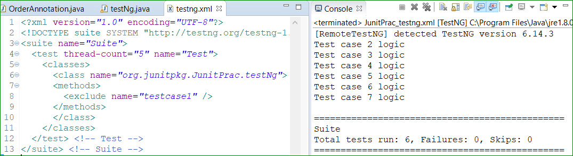

**Prioritization:**

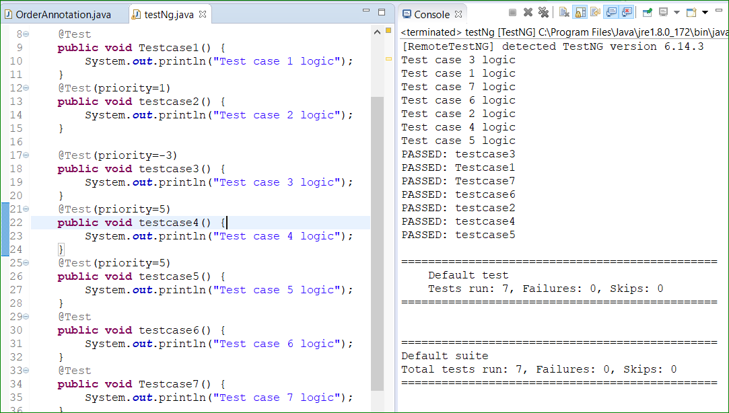

*Groups:*

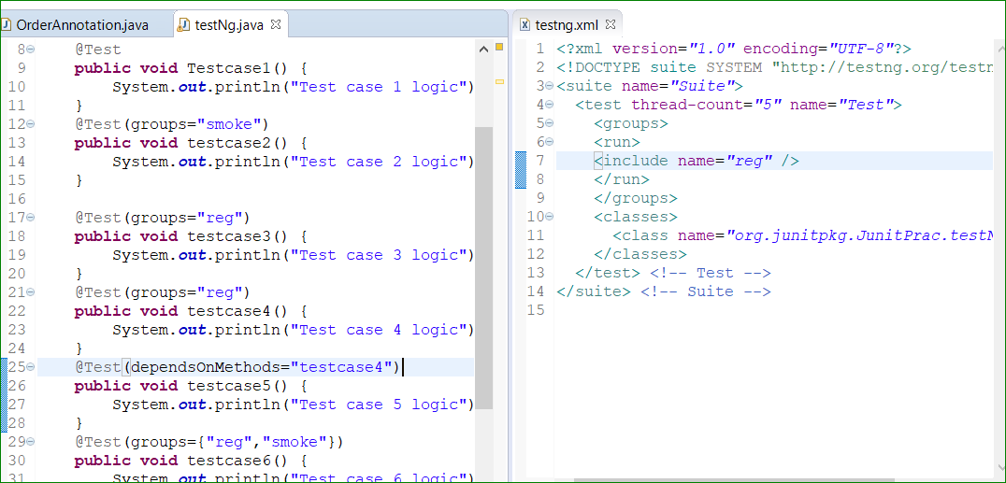

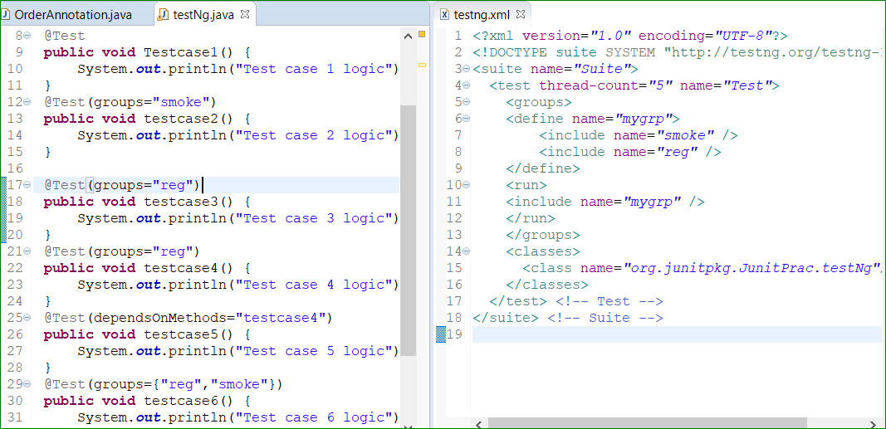

**Cucumber:**

In order to make the client understand the coding part or for developers to give the coding walkthrough, we need to write the coding in ‘English’ or Common understandable language.

***SDLC:***

1. Requirements –BA get the analysis or needed requirements from Client called as ‘BRD’ (business requirement Analysis.
2. Feasibility Analysis – BA gives the BRD to developers and Testers to do analysis. They will prepare the SRS(Software Requirement Specification) and send it to BA 🡪 Client (tools used for dev)
3. Design Development – Will design the UI screens of the entire Website or screen. Later, will showcase it to Client and get Approval.
4. Coding and Implementation – Developed Product
5. Testing Phase (Manual or Automation) – Quality Product
6. Deployment and Maintenance

UAT –User Acceptance Testing

**AGILE:**

Instead of fully

**Smoke Testing – High level functionality – Happy path Testing – Only positive**

* **Login**
* **Order Placement**
* **Search product**
* **Category search**
* **Create account**

**Sanity Testing – Checks only for the new changes thoroughly**

**Regression Testing – All in-depth testing for all functionalities**

**End to End Testing – Complete Flow of Test cases**